Poznań, 27th August 2020

Winners of the Gold Medal Competition at the DREMA 2020 Fair

We already know the winners of the Gold Medal Competition at DREMA 2020. The jury honored five products distinguished by their innovation. Meet this year's winners. All awarded Gold Medals are equivalent.

The Gold Medal is not only prestige but also measurable benefits for the winners. It is an award setting market trends and at the same time the most recognizable trade fair trophy in Poland. As many as 95% of the competition participants use the awarded distinctions in their promotional activities, and 55% of them declare an increase in sales of the awarded products.

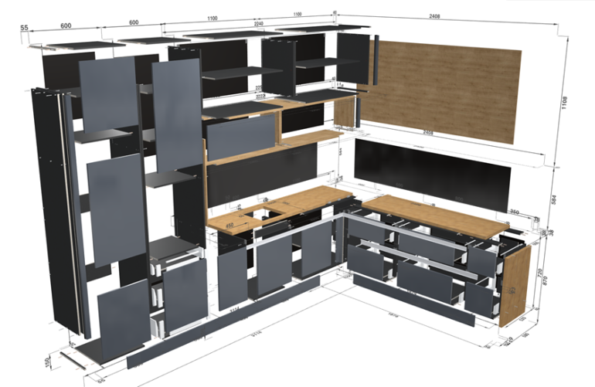
ABRYS SysTEM - Online Software for Furniture Design and Configuration, Order-Controlled Sales and Production

ABRYS Maciej Rezner - applicant and producer

hall 5, stand 33
Extraordinary times require innovative and complete solutions. One of them is ABRYS SysTEM, which is a 100% online solution, covering the entire process from furniture configuration to its production. ABRYS SysTEM is the only 100% online solution in the world, covering the entire process from furniture configuration to its production. ABRYS SysTEM uses a dozen or so servers scattered all over Europe (Germany, Italy, Czech Republic, Poland...) of renowned international data-centers to provide its clients with security and continuity of work. After the job has been processed, all data for production is automatically sent to the user's computer for production and archiving.
Personal or sensitive data are not sent to ABRYS SysTEM. If users want to store other sensitive data in ABRYS SysTEM, they are automatically encrypted in the program. All designs are automatically replicated (copied) simultaneously on several servers in several countries, thanks to which we have a full guarantee of their security.

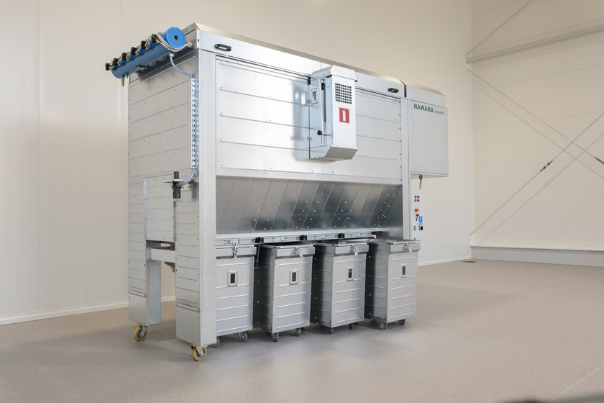
VACO MAX Jet Dust Collector

NAWARA SERWIS s.c. Marzena i Rafał Nawara - applicant and producer

hall 5, stand 4
VACOMAX jet dust collector is dedicated to tasks related to the extraction of wood waste directly at a specified point, which is guaranteed by its quality and safety, and which simply pays off. High efficiency as well as high air filtration parameters make the dust collector an eco-innovative product.

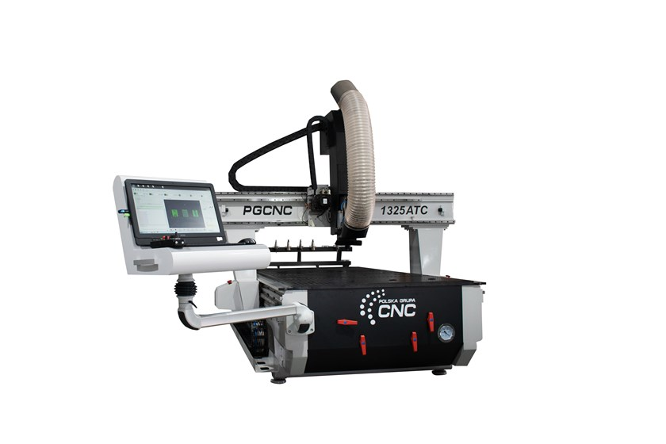
1325 ATC Milling Plotter
POLSKA GRUPA CNC Damian Laskowski - applicant and producer
hall 5, stand 32
A device for processing engineering materials ensuring ergonomics, space saving and easy transport while maintaining all technical properties. Our ATC plotter is an innovative solution by integrating the console and the control cabinet in a single solid. This series features an additionally reinforced structure and AC servo drives on each axis. The use of light and durable metal alloys ensures greater machine dynamics. These solutions create a very competitive product at an affordable price.

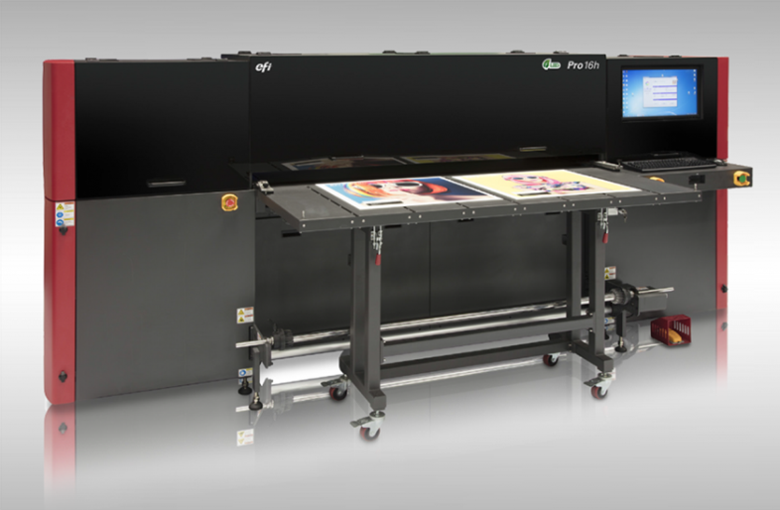
LED-UV EFI PRO 16H Plotter
ATRIUM Centrum Ploterowe Sp. z o.o. - applicant and producer
hall 5, stand 50
The EFI Pro 16h hybrid plotter has been designed to guarantee a competitive investment cost and low operating costs, without losing the unrivalled print quality and extensive possibilities of printing on various materials such as furniture boards, mdf, plywood, glass, plexiglass, ceramics, concrete and many others. The machine is used in the furniture and interior design industry due to the high demand for space personalisation. Thanks to the hybrid structure, we can print on flexible and rigid materials with a width of up to 165 cm and thickness of up to 5 cm. The ink used in the plotter is fully eco-friendly and has the GreenGuard Gold certificate.

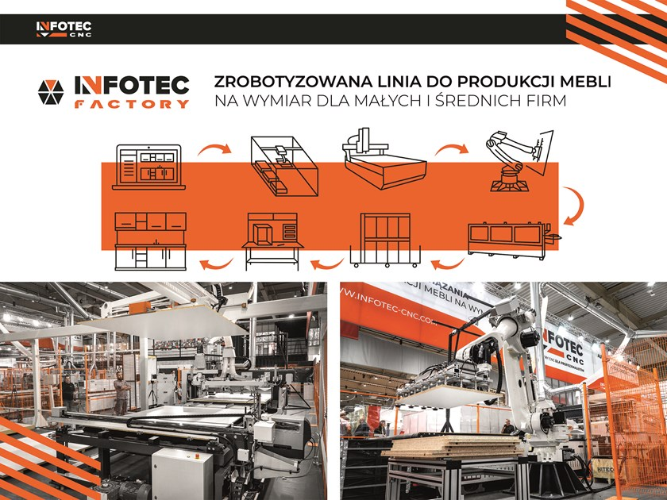
A robotic line for the production of custom-made furniture for small and medium-sized companies
hall 5, stand 33
InfoTEC FACTORY – a robotic line for the production of custom-made furniture up to the assembly stage. The InfoTEC FACTORY digital environment is dedicated to small and medium-sized furniture manufacturers who strive for fully automatic and flexible production. InfoTEC FACTORY can be implemented in the existing production process in stages, which allows you to spread the investment over time and gradually get rid of traditional production methods.

