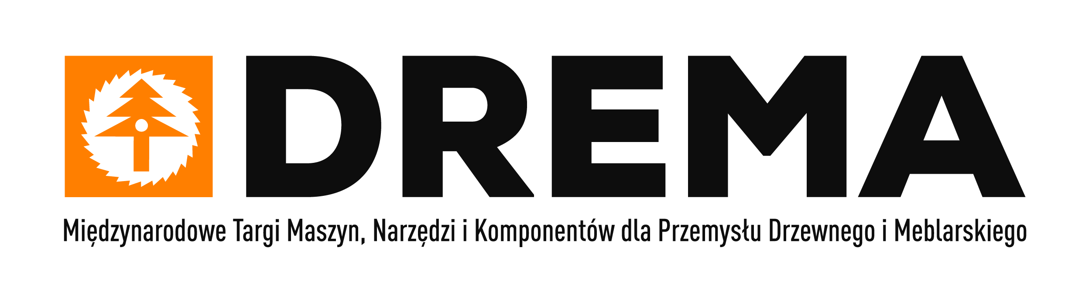

**DREMA 2025 - a solution to the crisis**

**The recent period has not been favourable for the wood and furniture industries. Companies in these sectors are suffering from high prices of raw wood, labour and electricity costs, declining orders and exports of furniture and wood products, as well as interruptions in supply chains. How to cope with market volatility and survive difficult times? In September professionals will try to answer this question in Poznan, during DREMA 2025 – the most important meeting of the wood and furniture industry in Central and Eastern Europe.**

Poland is still the world's leading furniture exporter. However, there is a lot of competition in the furniture market, both from Asian producers and from Central and Eastern European countries. With rising production costs, maintaining a strong international position of the Polish furniture industry requires companies to take many actions, including investing in solutions that will help optimise production and minimise its negative impact on the natural environment.

**Robotisation and automation in the spotlight**

These challenges will be addressed by the latest solutions in the field of robotisation and automation of technological processes presented during Drema 2025 Trade Fair. They are designed to significantly reduce production costs and, consequently, improve the efficiency, quality and sustainable development of woodworking and furniture production. The exhibition will cover both the automation and digitization of processes, the robotisation of workplaces, as well as the use of new materials and technologies – all with the aim of ultimately increasing the profitability of companies in the wood and furniture industries.

**41. DREMA recommended by EUMABOIS**

DREMA 2025 was once again the only event organized in Poland, which has been included in the list of 7 world exhibitions recommended by **EUMABOIS** – the European Federation of Woodworking Machinery Manufacturers. This year, the Drema Fair will be held for the 41st time. Last year's anniversary edition confirmed the unique position and role of this event in setting directions for the development of the industry. Approximately **400 companies and brands from 17 countries** presented their offers in Poznań. The stands presented a lot of advanced technological innovations and market premieres, designed to improve the efficiency and quality of production. The exhibition area of 20,500 sq. m (23% larger than previously) attracted a wide group of over 11,000 professionals from the woodworking and furniture production sectors. The **visitors** included representatives of **32 countries** with a large representation of specialists from Central and Eastern European countries.

The 2025 edition promises to be equally successful. **From 9 to 12 September 2025** the latest technologies for the wood and furniture industries will once again fill the halls of the Poznań International Fair. Although there is still more than half a year left until the start of DREMA trade fair, the list of companies interested in participating is already very long. The fair will feature a large representation of key companies from the innovation sector, a broad presentation of machines in motion and woodworking equipment, and a comprehensive supply offer for furniture manufacturers (raw materials, components, technologies, machines and tools).

**A good program for difficult times**

Market premieres and industry novelties are just one of the factors determining participation in the DREMA fair. Increasingly, the magnet that attracts all enthusiasts of modern technologies to Poznań is the program of accompanying events that complement the innovative exhibition. This year, it will include a lot of practical knowledge on process automation, robotisation, digital transformation and ways to ensure production continuity in unpredictable times. Experts will present not only trends and optimal directions of change, but also advise on how to implement them effectively.

Representatives of the wood sector will certainly be interested in **KOOPDREW (Wood Industry Congress)**  - an international conference of the Polish Chamber of Commerce of the Wood Industry, addressing topics related to threats and challenges for the wood industry in Poland and around the world. In turn, experts from the Polish Chamber of Commerce of Furniture Manufacturers (OIGPM) during the **Polish Furniture Congress** will discuss potential directions of the sector and ways to prepare for new economic phenomena. The OIGPM is also preparing another **Meeting of Women of the Furniture Industry**.

**The Technologists Forum lecture series will also be continued, the first edition of the forum took place in 2024 and was met with great interest from participants. This event is intended for technologists of the wood and furniture industries. Topics of the lectures will be mainly related to robotisation and automation of production processes. Participation in the forum will be an opportunity to gain the latest specialist knowledge and exchange experiences in the implementation of modern technologies.**

The innovations discussed at the Technologists Forum will be available to see in action right away as part of the **Live Furniture Factory – Drema for Children** – i.e. live demonstrations of the latest technologies in the production of furniture/wooden products using Polish machines. The factory will also produce children's furniture for charity purposes.

There will be no shortage of permanent program items:the **Furniture Trend Zone** – a place to present the latest furniture design (boards, fabrics, fittings), the **Parquet Zone** with parquet flooring shows and workshops – managed by the Polish Parquet Flooring Association, the **Skills Testing Ground** and painting demonstrations prepared by the Lakiernictwo Przemysłowe (Industrial Painting) magazine, the **DREMA Tools** space organized in cooperation with ITA Tools, where innovative tool sharpening and regeneration technologies will be presented live, the **Clean Air Zone** with an exhibition of modern and ecological solutions and heating systems prepared by the Biomasa Magazine, the exhibition of competition exhibits **Conjured from Wood** and **the Polish Championships in Nail Hammering** organized by the Inwestor Publishing House.

**The DREMA International Trade Fair of Machines, Tools and Components for the Wood and Furniture Industries will be held from 9 to 12 September 2025 at the fairgrounds of MTP Poznań Expo – come and visit us.**

**More at:** [**https://drema.pl/pl/**](https://drema.pl/pl/)